1. Open the stack of images
2. Image🡪Hyperstack🡪Stack to Hyperstack
3. Image🡪Color🡪Split Channels
4. Change the labeling images (channel 2) to 32 bit
5. Image🡪Stacks🡪Z project🡪Projection Type: median
6. On the mean image- Analyze🡪Measure – copy the mean value
7. Using the calculator plus plugin: Plugins🡪Scripts🡪Calculator Plus:

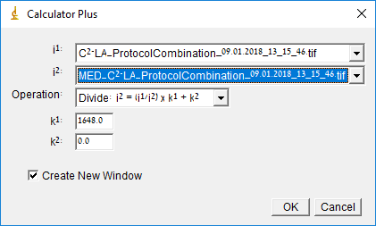

1. Change the new stack to 16-bit
2. Image🡪Color🡪Merge Channels:

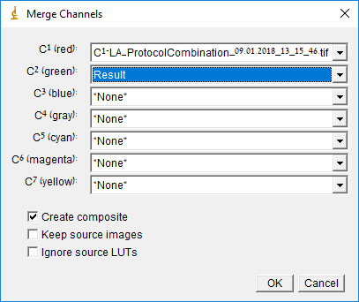

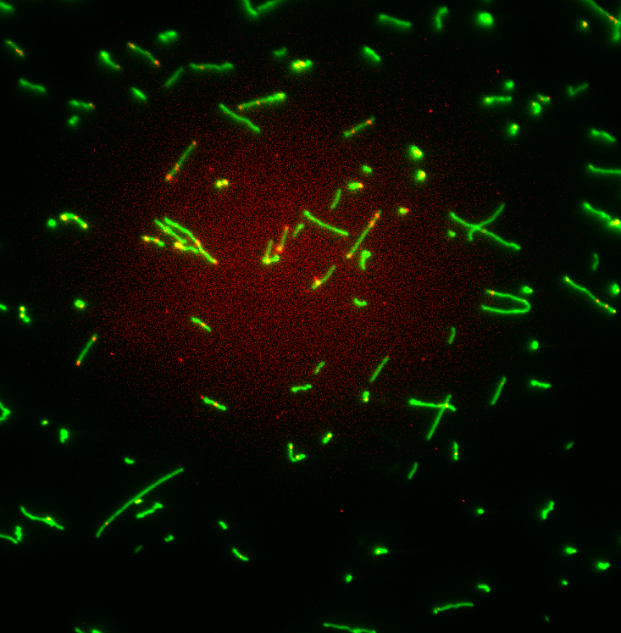 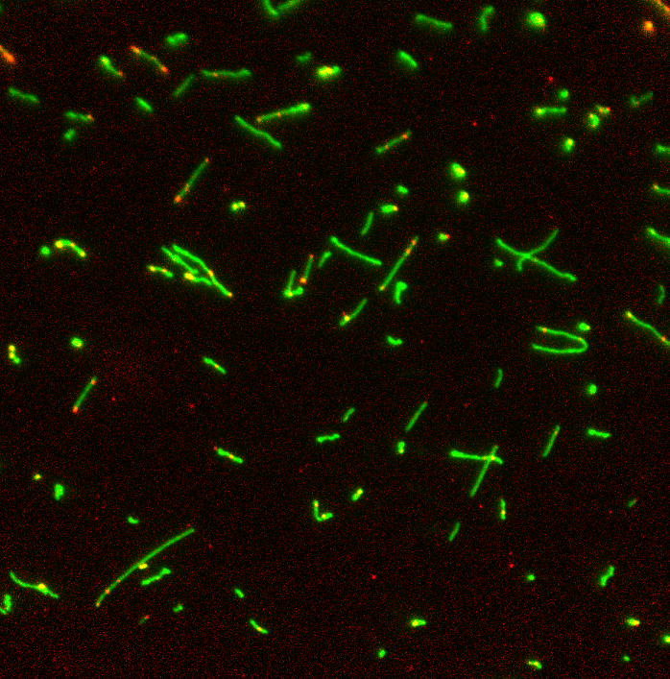

Before After